Hocking College Dental Hygiene Program
Application Packet

APPLICATION DEADLINE FOR CONSIDERATION OF AUTUMN 2019 CLASS:
JUNE 21, 2019

Dear Student,

Thank you for your interest in the Hocking College Dental Hygiene Program. The dental hygiene education curriculum is scientifically oriented, rigorous, and intensive. Total enrollment is based on facility capacity and specific program admissions criteria. These procedures are necessary to ensure that the students selected have the potential for successfully completing the program.

PLEASE BE SURE TO READ ALL INFORMATION IN THIS PACKET TO ENSURE YOU SUBMIT A COMPETE APPLICATION. THE DENTAL HYGIENE PROGRAM WILL NOT CONSIDER AN INCOMPLETE APPLICATION. IT IS THE RESPONSIBILITY OF THE APPLICANT TO ENSURE THE APPLICATION IS COMPLETE.

Admission to the dental hygiene program is selective and competitive. Selection is based on a formula of specific criteria. The twenty (20) highest ranking candidates will be offered program admission.

CONTACT INFORMATION:

Allied Health Office Manager: Leanna Grey
Greyl32771@hocking.edu
(740) 753-6376
Davidson Hall – DVD 217

Dental Hygiene Program: Alaina Himes
himesa@hocking.edu
(740) 753-6460
Davidson Hall – DVD 330
IMPORTANT INFORMATION REGARDING PROGRAM REQUIREMENTS

In order to accomplish the objectives of the dental hygiene program, students must be able to meet the following performance requirements:

Professional Attitude: It is important for a dental hygienist to interact professionally with patients, coworkers, employers, and other health care professionals. Therefore, if at any time during the application process it is determined that your attitude or actions are unprofessional, your application may not be considered for acceptance.

Ability to visually identify oral tissue changes and evaluate treatment effectiveness is essential to the dental hygiene professional.

Ability to hear in order to understand the normal speaking voice without viewing the speaker’s face and take/hear blood pressure with a stethoscope.

Physical ability to sit for prolonged periods of time, perform repetitive wrist motion for instrumentation, and move from room to room or maneuver in limited spaces.

Written and verbal communication skills to succinctly describe patient conditions, document findings in a patient record, and implement oral health teachings.

Manual dexterity to use a variety of instruments in the small, confined space of the oral cavity.

Function safely under stressful conditions with the ability to adapt to an ever changing environment inherent in clinic situations involving patient care.

Computer skills to use a variety of software programs and the internet for research and course projects. Power point is used for presentations.

Hepatitis B Vaccination will be required prior to beginning patient treatment clinical portions of the program. This is a three series vaccination. CPR certification will be required after acceptance to the program.

Dental patients and dental health care workers may be exposed to a variety of microorganisms via blood or oral and respiratory secretions. These microorganisms may include the Hepatitis B virus (HBV), Hepatitis C virus (HBC), herpes simplex virus type 1 and 2, human immunodeficiency virus (HIV), Mycobacterium tuberculosis, staphylococci, streptococci, and other viruses and bacteria-specifically, those that infect the upper respiratory tract. Infections may be transmitted in the dental operatory through contact with contaminated instruments, operatory equipment, or environmental surfaces: contact with airborne contaminants present in either droplet spatter or aerosols of oral and respiratory fluids. Effective infection control strategies are intended to prevent infection.

DENTAL HYGIENE PROGRAM OUTCOMES:

Upon successful completion of the Dental Hygiene Program, the graduate will be able to:
- Apply theoretical principles and perform procedures relevant to the dental hygiene practice, routinely self-assessing performance abilities to ensure a high standard of care.
- Determine the need and extent of patient-centered treatment utilizing critical thinking skills, including radiographic exposure, routine preventative procedures, periodontal therapy procedures, referral for additional assessment and/or treatment, response to medical/dental emergencies, and all other treatment needs.
- Utilize the dental hygiene process of care in the prevention and/or treatment of oral diseases: assessment, dental hygiene diagnosis, planning, implementation, evaluation, and documentation.
- Apply oral health literacy utilizing analysis of current research literature to provide oral and overall health promotion to individual patients and the community using evidence-based information.
- Utilize standard precautions for infection control during all phases of appointment planning, patient interaction, and treatment.
- Discern and manage ethical issues (using Dental Hygiene Code of Ethics and federal and state laws), exercise sound clinical judgement, and collaborate with diverse populations of professionals and patients.

DENTAL HYGIENE CURRICULUM SCHEDULE:

First Semester
BIOS 1113 Anatomy & Physiology I
GS 1000 HC Cornerstone
ENGL 1510 English Composition I
MATH 2250 Introductory Statistics
PSYC 1101 Psychology

>>>>SELECTIVE ADMISSION<<<<

Second Semester
DHYG 1101 DH Theory & Instrumentation
DHYG 1102 Orofacial Anatomy, Histology,
& Embryology
DHYG 1103 Dental Radiology
*BIOS 1114 Anatomy & Physiology II

Summer Semester
DHYG 1111 Clinical Dental Hygienist I
DHYG 1112 Dental Hygiene Concepts
DHYG 1113 Community Dentistry
DHYG 1114 Local Anesthesia & Pain
Control
DHYG 1115 Dental Materials
DHYG 1116 Periodontology
Third Semester
DHYG 2101 Clinical Dental Hygienist II
DHYG 2102 Pharmacology
DHYG 2103 General & Oral Pathology
*MICR 1201 Microbiology

Fourth Semester
DHYG 2201 Clinical Dental Hygienist III
DHYG 2202 DH Capstone
*COMM 1130 Speech
*SOCI 1101 Sociology

TOTAL CREDIT HOURS: 73.00

*General Education courses (other than prerequisite courses) may be taken during the program, or prior to admission to the Dental Hygiene Program.

TRANSFERABILITY OF DENTAL HYGIENE PROGRAM COURSES:

Due to the technical nature of the dental hygiene courses, it is unlikely that they will transfer to other institutions. Likewise, Hocking College Dental Hygiene Program does not accept transfer credits for dental hygiene program courses taken at other institutions in place of the required courses at Hocking College.

SCOPE OF PRACTICE FOR DENTAL HYGIENISTS:
Ohio dental hygienists provide the following oral health services as permitted by the Ohio State Dental Board’s Dental Practice Act:
- Administration of local anesthesia
- Administration of nitrous oxide-oxygen minimal sedation
- Monitoring nitrous oxide-oxygen minimal sedation
- Removal of calcareous deposits or accretions from the crowns and roots of teeth.
- Periodontal scaling, root planing, and soft tissue curettage.
- Sulcular placement of prescribed materials.
- Bleaching of teeth
- Pit and fissure sealants.
- Radiologic procedures
- Taking impressions
- Fluoride application.
- Nutritional counseling as it relates to dental health
- Oral hygiene instruction
- Other patient treatment and documentation procedures within guidelines

EMPLOYMENT OPPORTUNITIES FOR DENTAL HYGIENISTS:

According to the US Department of Labor, the job opportunities for dental hygienists is expected to grow much faster than average through the year 2024. An estimated 17% increase in employment is expected in Ohio and 19% increase throughout the United States.

Dental Hygienists are typically employed:
- In private dental practices
- In community clinics
- In college/university dental clinics
- In prison facilities
- In school sealant programs
- To work in underserved populations such as nursing homes

Application and Admission to the Dental Hygiene Program

Application and admission to the Dental Hygiene Program is a separate procedure from application and admission to Hocking College. Admission to Hocking College does not ensure admission into the Dental Hygiene Program. Any Hocking College student may declare Dental Hygiene as a major, enroll, and complete general education courses required for a program degree without having been specifically admitted to that program. However, only those students who have been admitted to the Dental Hygiene Program may enroll in the dental hygiene (DHYG) courses. You must apply for the dental hygiene program one year at a time. There is no waiting list. If you are not accepted, you must reapply for a later year. The candidates receiving the most points in the admissions process will be offered entrance into program. Students will be notified by email of their admission status: ‘Accepted or Not Accepted’. All statements related to admission criteria or announcements of present policies are subject to revisions as needed. Any advice given by the dental hygiene department regarding coursework does not ensure acceptance into the program.

Admissions are determined on an objective basis using a quantified point scale. The scale is designed to accurately predict a student’s successful completion of the program and passage of external board exams.

Admissions ranking criteria include:

Minimum requirements for consideration of admission to the Hocking College Dental Hygiene Program include:
- Minimum cumulative college GPA of 2.6
- BIOS 1113:Anatomy & Physiology I (must achieve a ‘C’ 73% or better)
- GS 1010: Pathway to Prosperity (must achieve a ‘C’ 73% or better)
- ENGL 1510: English Composition I (must achieve a ‘C’ 73% or better)
- MATH 2250: Introductory Statistics (must achieve a ‘C’ 73% or better)
- PSYC 1101: General Psychology (must achieve a ‘C’ 73% or better)
- Minimum of 18 observation hours in dental offices
- TEAS entrance exam, three attempts allowed: total score of 55% or better, Reading content area score of 65% or better, English & Language Usage content area score of
65 % or better
- Deductions may be applied for any unprofessional attitude or behavior during communication or admission process

All applicants will be scored using the following system. Admission is granted to the applicants with the highest scores using this system.

COLLEGE COURSE GPA
Minimum GPA is 2.6

Cumulative College GPA | GPA 4.0 | GPA 3.8-3.9 | GPA 3.6-3.7 | GPA 3.4-3.5 | GPA 3.2-3.3 | GPA 3.0-3.1 | GPA 2.8-2.9 | GPA 2.6-2.7 | GPA < 2.6
Points Awarded | 4.5 | 4.0 | 3.5 | 3.0 | 2.5 | 2.0 | 1.5 | 1.0 | Ineligible

PREREQUISITE COURSES
Must achieve a ‘C’ in all prerequisite courses, equaling 73% minimum grade

COURSE | GRADE OF ‘A’ | GRADE OF ‘B’ | GRADE OF ‘C’ (minimum 73%)
BIOS 1113: Anatomy & Physiology I | 3 | 2 | 1
GS 1000: HC Cornerstone | 3 | 2 | 1
ENGL 1510: English Composition I | 3 | 2 | 1
MATH 2250: Introductory Statistics | 3 | 2 | 1
PSYC 1101: Psychology | 3 | 2 | 1

TEAS EXAM SCORE
Must achieve a total score of 55% or greater for consideration of admission. Must achieve a score of 65% in both the ‘Reading’ and ‘English & Language Usage’ content areas. Three attempts are allowed.

Total Score | 90.1% - 100% | 80.1% - 90.0% | 70.1% - 80.0% | 65.0% - 70.0% | 60.1% - 64.9% | 55.0% - 60.0%
Points Awarded | 3.5 | 3.0 | 2.5 | 2.0 | 1.5 | 1.0

Reading Score | 95.0% - 100% | 90.1% - 94.9% | 85.0% - 90.0% | 80.1% - 84.9% | 75.0%-80.0% | 70.1% - 74.9% | 65.0% - 70.0%
Points Awarded | 4.0 | 3.5 | 3.0 | 2.5 | 2.0 | 1.5 | 1.0

E & L.U. Score | 95.0% - 100% | 90.1% - 94.9% | 85.0% - 90.0% | 80.1% - 84.9% | 75.0%-80.0% | 70.1% - 74.9% | 65.0% - 70.0%
Points Awarded | 4.0 | 3.5 | 3.0 | 2.5 | 2.0 | 1.5 | 1.0

APPLICATION PROCEDURE:

The following application procedure must be followed for your application to be considered complete:
- Complete application to Hocking College.
- Order 2 official transcripts from every college or university attended.
- Students must maintain a minimum cumulative grade point average in college level courses of 2.6 or better.
- One official transcript from other colleges or universities will be sent to the Hocking College admissions office and one will be turned in with your dental hygiene program application in the original sealed envelope.
- Complete the TEAS exam, attaining at least the minimum scores. Three attempts are allowed.
- Complete application to the Hocking College Dental Hygiene Program.
- Criminal history form provided to Hocking College Police Department or other applicable organization. Form is found on website: www.hocking.edu/dental-hygiene. Results will be returned to Hocking College.
Hocking College does not discriminate against qualified applicants with disabilities in any of its programs including the Dental Hygiene Program. The Access Center/Office of Disabilities Services in DVD 114 is dedicated to serving the various needs of individuals with documented disabilities and to promoting their full participation in college life. They will assist persons interested in seeking admission to any program to understand the program requirements and determine whether and how their disability can be accommodated in the program.
In addition, a person with disabilities who is interested in pursuing a career in dental hygiene might wish to consult with a dental professional concerning whether the nature of the disability may be an impediment to hiring in the specific office settings in which there is interest before commencing the program.
HOCKING COLLEGE
DENTAL HYGIENE PROGRAM
Program Application Checklist

Apply for general admission to Hocking College at: www.hocking.edu/apply-to-hocking -Choose Dental Hygiene as program/major
Submit official transcript(s) from all college(s)/university(ies) attended to Hocking College registrar: www.hocking.edu/registrar

SUBMIT TO DENTAL HYGIENE PROGRAM PERSONNEL:
Dental Hygiene Program application
Office observation forms (minimum of 18 hours, forms are included in this packet)
TEAS scores will be accessed by Hocking College faculty and staff (three attempts allowed, see required scores listed above)
Official transcript(s) from all college(s)/university(ies) attended
Criminal history results will be received from police department or other office

DO NOT SUBMIT APPLICATION UNTIL ALL REQUIREMENTS AND PAPERWORK ARE COMPLETED; DEADLINE FOR APPLICATION SUBMISSION WILL BE DETERMINED AFTER PROGRAM RECEIVES ACCREDITATION THROUGH CODA.

All information must be included for your application to be complete. Any piece of missing documentation will result in the application not being considered for admission.

IT IS RECOMMENDED THAT YOU RETAIN COPIES OF THE APPLICATION YOU SUBMIT.

If reapplication at future dates is necessary, any information from previous applications will not be released.

Information is not accepted via FAX other than the observation form. All forms must be delivered in person or by postal mail to the Allied Health Office Manager or Dental Hygiene Personnel.

Please notify program secretary or faculty regarding any change of address, phone number, or email address as soon as possible.

TEAS INFORMATION
Last date to take TEAS entrance exam as part of application for Autumn 2019: June 7, 2019

The ATI TEAS has four content areas (Reading, Mathematics, Science, and English and Language Usage) each of which is comprised of several sub content areas (e.g., Key Ideas and Details, Craft and Structure). Adjusted percent correct scores that range from 0.0% to 100% are provided for each of the content areas. These scores are equated scores, meaning they are adjusted to account for possible differences in difficulty across questions. The percentage of questions answered correctly in each sub content area is also provided. A total score is also provided and indicates one’s overall preparedness for early success in a health sciences program. The total score is an adjusted percent correct score which ranges from 0.0% to 100%. It is an equated score generated by the information from the entire set of 150 scored questions.

Registration for the TEAS Exam is done at: www.atitesting.com/teas
The TEAS Exam must be taken at the Hocking College testing center on the main campus in Nelsonville, OH. An applicant may take the TEAS exam up to three (3) times in association with application to the Hocking College Dental Hygiene Program. The testing center is located on the first floor of Davidson Hall. Make sure to select ‘Hocking College AH’ as your institution when setting up an account. The testing schedule allows for four (4) hours to complete the exam. Attached is information on registering to take the TEAS Exam.

HOCKING COLLEGE DENTAL HYGIENE PROGRAM
Student Application for Selective Admission
APPLICATION DEADLINE: JUNE 21, 2019

Personal Information (please write/type clearly)
- Name: Student ID

- Other name under which credential may be received:

- Social Security Number:

- Permanent Address:

- Mailing Address:

- Cell Phone Number:

- Work or Other Applicable Phone Number:

- Email Address:

- _____ I have previously attended Hocking College. Last term attended ___________
_____ I am currently attending Hocking College.

- Are you a citizen or permanent resident of the United States? ____Yes ____ No
If ‘No’ the Ohio State Dental Board will not allow licensure for employment. Please consult the Ohio State Dental Board if you have questions or concerns: (614) 466-2580
(Please supply a copy of your permanent resident card, if applicable)

Educational Information
- List all educational institutions (colleges, universities, professional schools) in order of attendance.
- Do not omit the name of any institution where you have been a student.
- If you need additional space use a separate sheet of paper.
School Name:
Date Attended: | Start: ___________ End: _____________
Credit Hours:
Degree/Certificate:

School Name:
Date Attended: | Start: ___________ End: _____________
Credit Hours:
Degree/Certificate:

School Name:
Date Attended: | Start: ___________ End: _____________
Credit Hours:
Degree/Certificate:

Provide the name, address, and telephone number of a person to be contacted in case of an emergency:
Name: ________________________________________
Address ________________________________________________________________
(Street) (City) (State) (Zip)
Phone: Cell: __________________________ Other: __________________________

Students with felony convictions may not be licensed by the State of Ohio to practice dental hygiene. Please consult the Ohio State Dental Board (614) 466-2580 if you have questions or concerns.

Acceptance is contingent upon a negative criminal history check.

I certify that information provided in this application is correct and complete. I understand that omission or falsification of information is grounds for exclusion or dismissal. If accepted into the program, I agree to meet all entrance requirements and to confirm and abide by the rules, regulations, and procedures of Hocking College and this program.

Signature: ______________________________________ Date: ______________________

Please return the completed Dental Hygiene Program Application including official transcripts, certifications, and any other necessary documentation to:
Hocking College
Dental Hygiene Program, DVD 309
3301 Hocking Parkway
Nelsonville, OH 47564

OBSERVATION EXPERIENCE IN THE DENTAL OFFICE

Requirement for Application for Admission into Hocking College’s Dental Hygiene Program

Applicant’s Name: __________________________________ HC Student ID: ____________

Dear Dental Professionals,

Thank you for taking the time to allow a prospective Hocking College Dental Hygiene student observe you in your daily work. This student is expected to observe in a minimum of two offices for a total of 18 hours with no limit on number of days utilized.

The student is encouraged to observe multiple procedures common in a dental practice. Preferred experiences include:
- Prophylaxis provided by a dental hygienist: scaling, polishing, application of fluoride
- Radiographic exposure and review of images
- Administration of local anesthesia
- Infection control and sterilization procedures
As a potential student in the dental hygiene program at Hocking College, proper attire is required during observation in all dental settings. During observation, please adhere to the following dress code:
- Hair should be away from face and shoulder and prevented from falling forward if leaning over.
- Scrubs, dress slacks, or khakis. No Jeans. No excessive amount of body exposed.
- Lab coat, if possible.
- No visible piercings or body art.
- Closed toe shoes.

DENTAL OFFICE INFORMATION: TO BE COMPLETED BY DENTAL PROFESSIONAL

Office Name, Phone, Address: _______________________________________________
_______________________________________________

Name of Supervising Dental Professional: ___________________________________________

Signature of Supervising Dental Professional: ________________________________________
Hours of Observation: _________________ Date: _____________________
Please contact the Hocking College Dental Hygiene Program with comments/concerns:
Phone: (740) 753-6460; Fax: (740) 753-6430; email: himesa@hocking.edu

APPLICANT: Attach this completed form to your application.

How to Register for the TEAS® Assessment
Find more information at the testing organization’s website: www.atitesting.com

Create a New Account
If you are not a current user on www.atitesting.com, you must create a new account to access the student portal or to make a purchase from ATI's online store. Follow the steps below to create a new account.

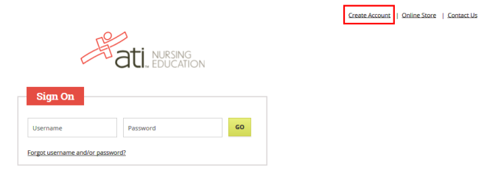
From the atitesting.com home page, click Create Account.

The Sign In Info page displays.

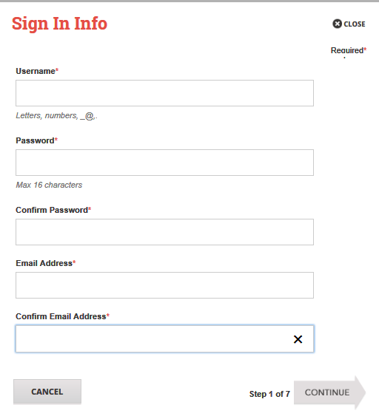
On the Sign In Info page, enter the account information that you will use to sign in to your account or to recover your account.

You must enter valid information into all the fields on this screen before you can proceed.

If your entry is not accepted, an error message similar to the one pictured below will display.

Reenter your information. When your entry is accepted, the message will disappear.

After you have entered all your account information, click Continue to go to the Security Questions page.

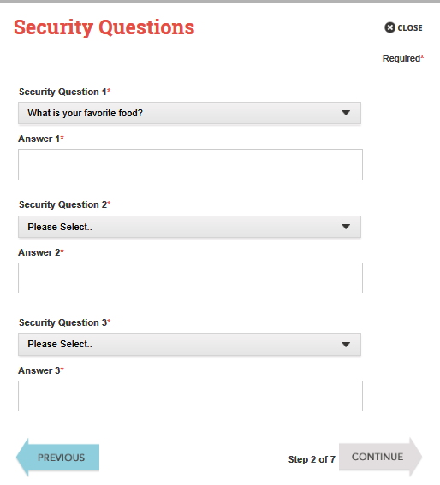
On the Security Questions page, select three different security questions, one from each list and enter your answer for each. Be sure to record your questions and answers for your future reference, in case you need to recover your account or you cannot remember your password.

Click Continue to enter your personal information.
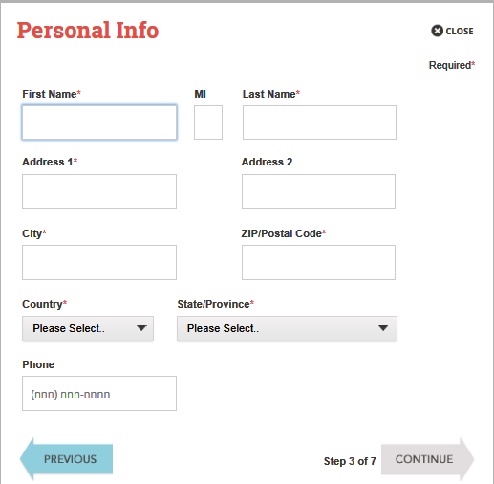
On the Personal Info page, enter your contact information. The following fields are required:
- First Name
- Last Name
- Address 1
- City
- ZIP/Postal Code
- Country
- State/Province

Click Continue to enter your Institution information.

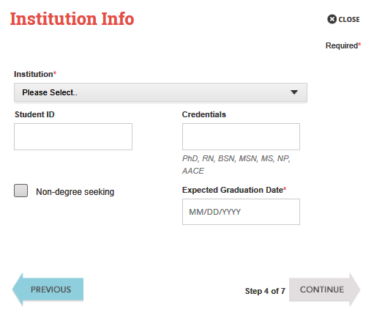
On the Institution Info page, select ‘Hocking College AH’ as your Institution from the list. All other fields are optional.

Click Continue to enter your Demographic Info.

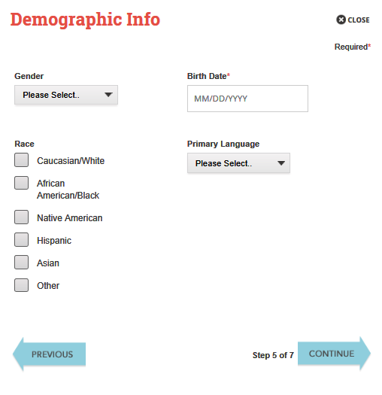
On the Demographic Info page, enter your Gender, Birth Date, Race, and Primary Language information. Only Birth Date is required.

Click Continue to go to Subscription, Updates & Notes.
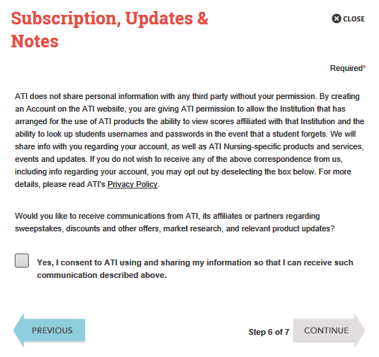
On the Subscription, Updates & Notes page, read the Subscription, Updates & Notes information.

If you agree to allow ATI to share your information under the terms presented on this screen, select the Yes, I consent check box.

Click Continue to go to User Terms and Conditions.

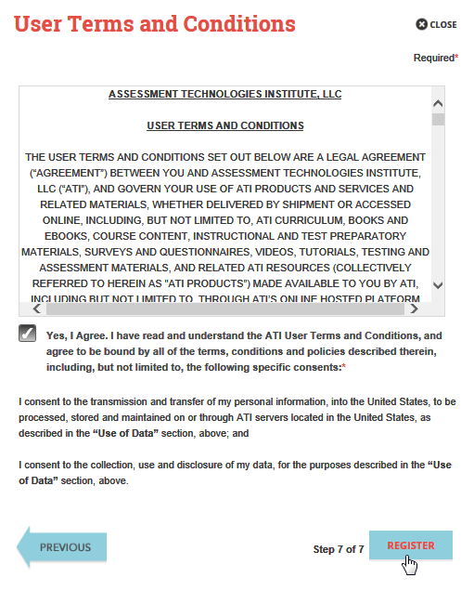
Click Register when you are finished creating your account.
Click Previous if you want to change any of the information you have entered for your new account.
On the User Terms and Conditions page, read the information under User Terms and Conditions.

Then select the Yes, I Agree check box to acknowledge that you have read the ATI User Terms and Conditions and agree to be bound by them.

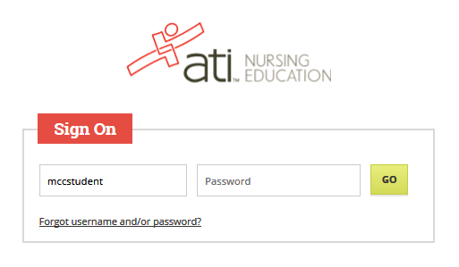
The Sign On window displays and your new Username is filled in for you. Enter your Password and click GO to launch the Student Home page.

You can now register for the TEAS® Assessment through our Online Store.

2. Sign on to your Account

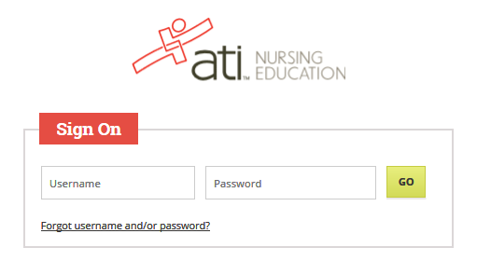
From the atitesting.com home page enter your Username and Password and click GO to launch the Student Home page.
Then, from the Student Home page, click Online Store in the upper right corner. The ATI Store page displays.

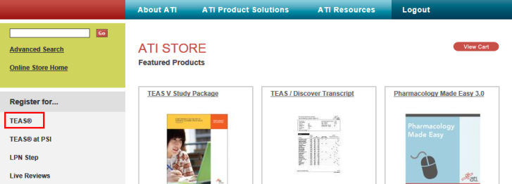
In the Register for column, click TEAS®. The Registration page displays.

Go to STEP 2: Register for a TEAS Session to continue.

- Register for a TEAS Session
Select a Program Type, based on your anticipated area of study:
- TEAS for Nursing Students
- TEAS for Allied Health
From the Country, State and City lists, select the location where you want to sit for the assessment and then click Next. The Browse Sessions page displays.
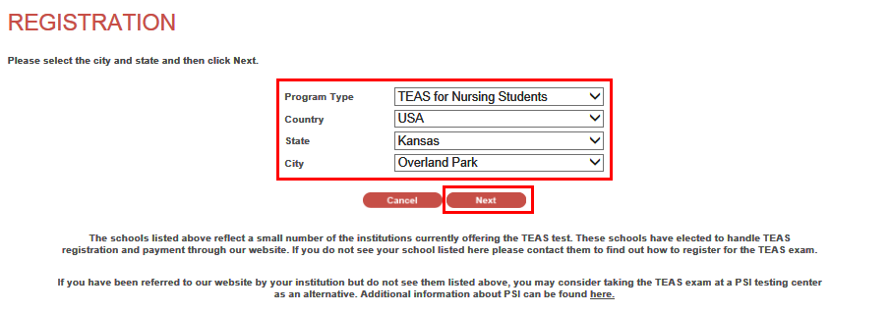
Do one of the following to register for a session:
- Click the Register button associated with the session for which you are registering.
- Click the Learn More button to open the Product Details window to view details about the session.
Note: If you don’t see a suitable location, you can expand your search by selecting All for the City and/or State.
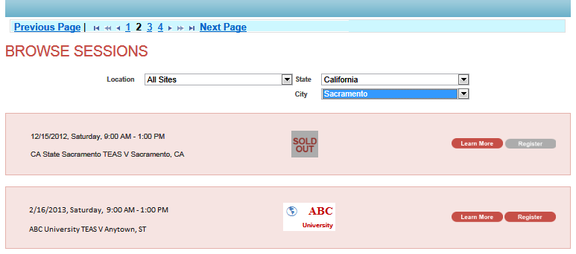

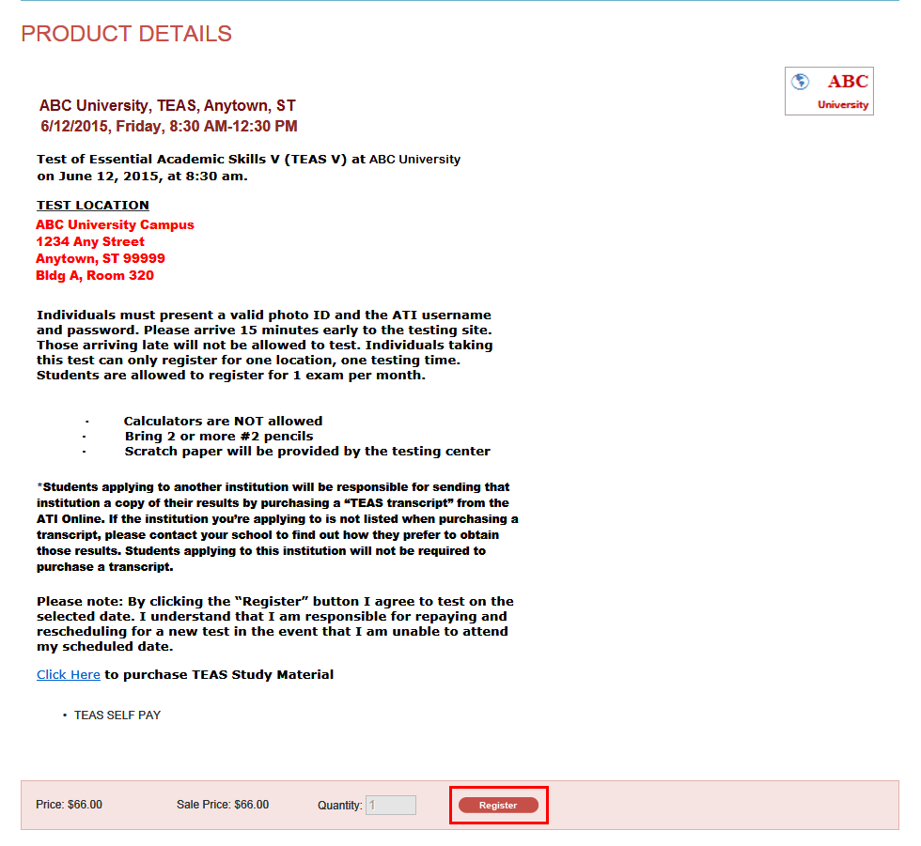
- If you clicked Register, skip to the next window.
- If you clicked Learn More, you opened this Product Details window. Review the information and then click Register to add this session to your online shopping cart or click the back button to go back to your Browse Sessions list.
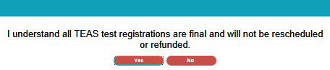
After you click Register, this window displays:

Click Yes to continue. Your Shopping Cart displays.
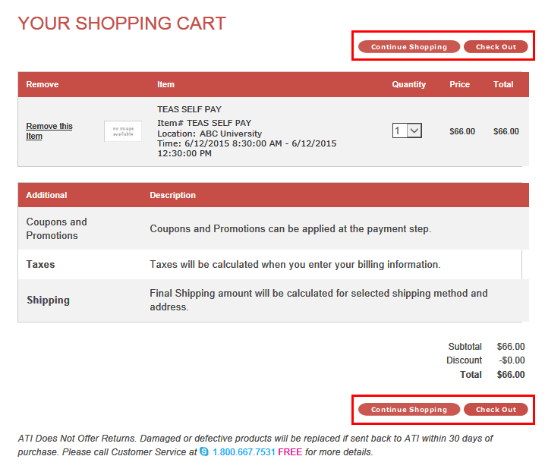
Review the information on the screen. At this point, you have the following options:
- If all the information is correct and you do not want to purchase additional items, click Check Out.
- If you want to make additional purchases, click Continue Shopping to return to the Online Store.
Note: Supporting TEAS items, such as study aids and extra transcripts, are available from the ATI Online Store. At the Online Store home page, enter TEAS in the Search field and then click Go to display all TEAS-related items.
- If you do not want to purchase the designated assessment, click Remove this Item. The session is removed from your Shopping Cart. Click Continue Shopping to return to the Online Store. Go back to choose a different TEAS Assessment session.
- IMPORTANT:
ATI does not offer refunds. Damaged or defective products will be replaced if sent back to ATI within 30 days of purchase. Please call Customer Service at 1.800.667.7531 for more details.

4. Check Out and Pay
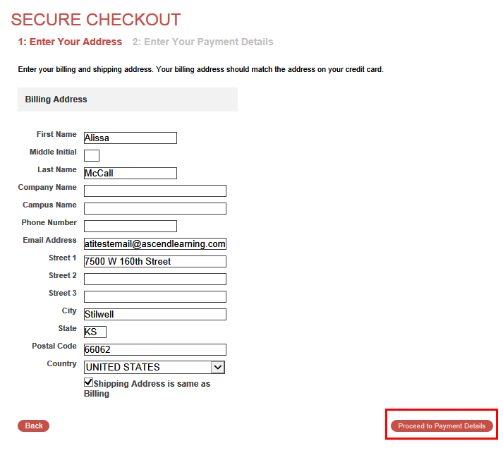
Enter/confirm your mailing address and provide any additional information and then click Proceed to Payment Details. The Secure Checkout: Payment Details screen displays.
Note: If any required information has not been filled in, you will be prompted to provide the information before you are allowed to continue

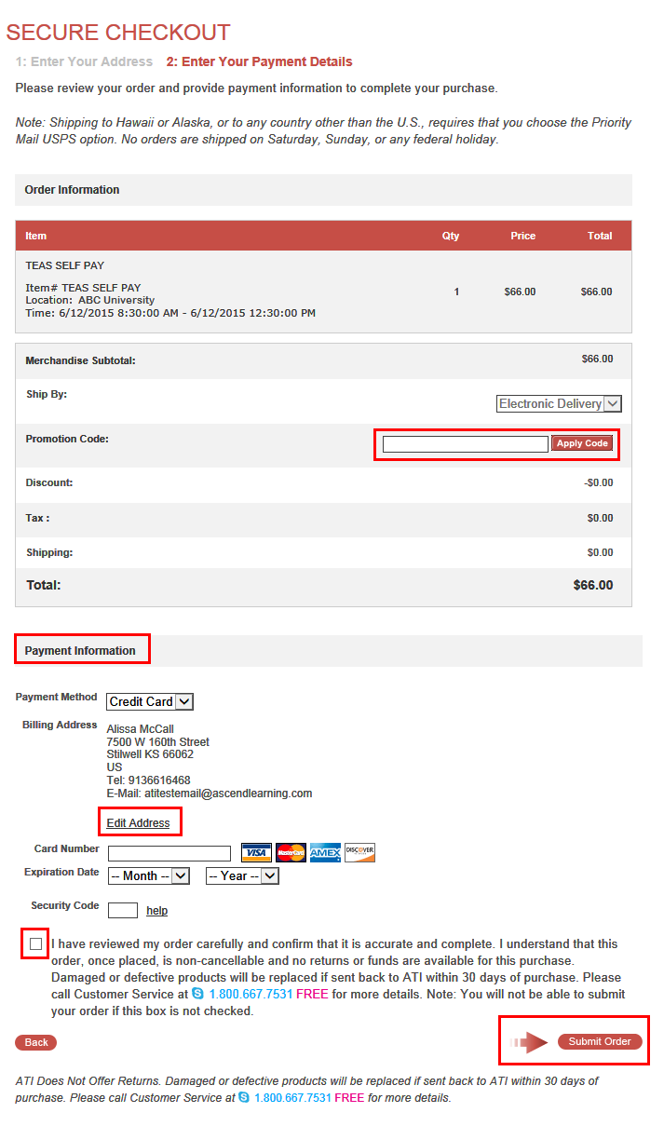
- In the Payment Information section, enter your credit card information.
- Check your address information and click Edit Address to change the billing information for your order.
- Read the information to the right of the check box. Then, select the check box to verify that your order is correct and that you have read and agree to the terms of your purchase.
- Click Submit Order.
If you have a Promotion Code, enter it into the Promotion Code field and then click Apply Code.

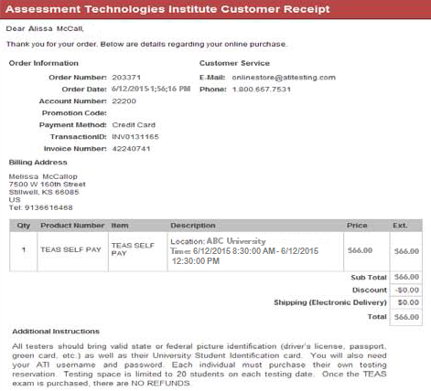 Go back to the top
After you click Submit Order, your Customer Receipt displays. Your receipt includes any additional instructions for your assessment. Your receipt will also be emailed to you to the email address listed in your profile.

